1. program for literals

a = 0b1010

b = 100

c = 0o310

d = 0x12c

float_1 = 10.5

float_2 = 1.5e2

x = 3.14j

print(a, b, c, d)

print(float_1, float_2)

print(x, x.imag, x.real)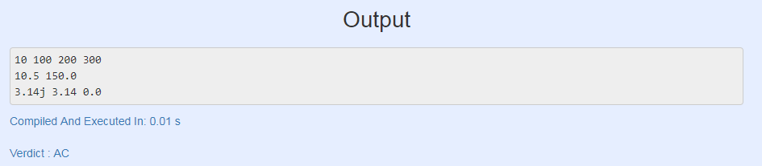

1. **Lists in Python**

# Declaring a list

L = [1, "a" , "string" , 1+2]

print (L)

L.append(6)

print (L)

L.pop()

print (L)

print (L[1])

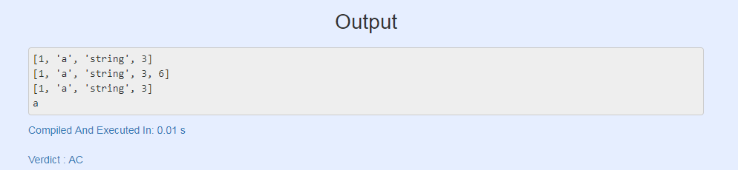

1. **Tuples in Python**

tup = (1, "a", "string", 1+2)

print (tup)

print (tup[1])

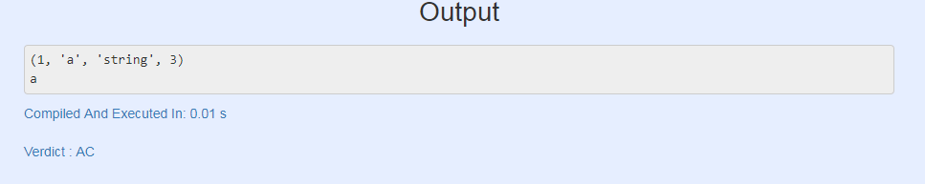

4 program dictionary in python

my_dict = {'name':'Jack', 'age': 26}

my_dict['age'] = 27

print(my_dict)

my_dict['address'] = 'Downtown'

print(my_dict)

